Understanding ICD Codes: A Layperson’s Guide to the “Language” of Disease
\*\*The International Classification of Diseases (ICD) is the world’s standard system for coding illnesses, injuries, and health conditions. Think of it as a giant library or catalog of diseases – except instead of using words, it uses alphanumeric codes to represent every medical condition. These codes are used globally by doctors, hospitals, and insurance companies to ensure that health conditions are recorded and communicated consistently across different places and languages. In this guide, we’ll break down what ICD codes are, how to read them, and what’s new in the latest version (ICD-11), in simple terms.
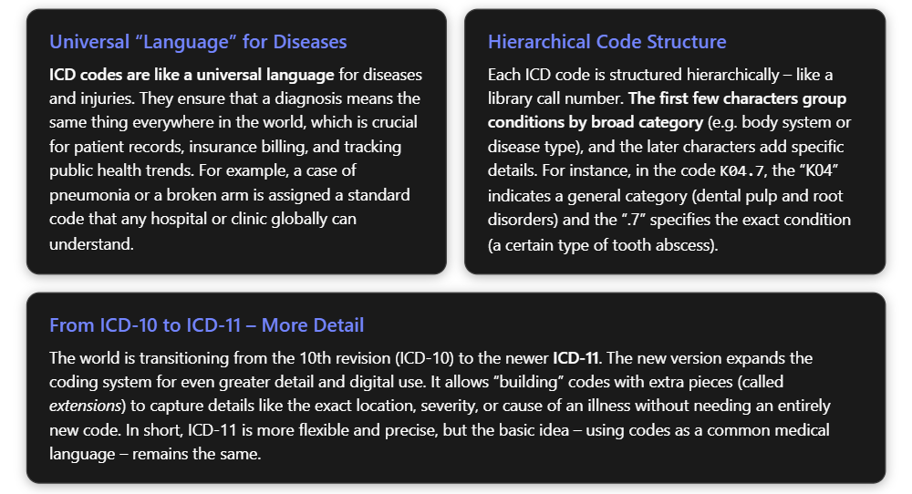

What Are ICD Codes, and Why Do We Need Them?
ICD codes are alphanumeric tags for health conditions. They might look complex at first glance, but they serve a simple purpose: to uniquely identify every disease or health problem. For example, instead of writing “Type 2 diabetes mellitus without complications” every time, a doctor can simply use the code E11.9 – which always means that exact condition in any clinic or hospital. This coding system is maintained by the World Health Organization and has been in use for over a century, evolving through multiple revisions as medical knowledge expands.
Why use codes? Imagine if every doctor described diagnoses in their own words – one might write “heart attack,” another “myocardial infarction,” another “cardiac infarction.” It could get confusing and error-prone. ICD provides a standardized vocabulary: each code is an agreed-upon label for a diagnosis, ensuring consistency across different regions, languages, and times. This has several practical benefits:
- Healthcare Communication: Codes allow doctors, hospitals, and insurers to communicate clearly. A code in a patient’s chart tells any future caregiver exactly what condition was diagnosed. For instance, if you travel abroad and need medical care, your ICD-coded health records can be understood by doctors even if they speak a different language.
- Insurance and Billing: Insurance companies require ICD codes on claims to process payments. These codes justify the medical services provided. For example, a treatment coded with a procedure code must be matched with a diagnosis code that explains why that procedure was needed.
- Public Health and Research: Health authorities use aggregated ICD code data to track disease prevalence, spot outbreaks, and allocate resources. If influenza cases are spiking in a region (all coded as J10 or J11 in ICD-10 for different types of flu), public health officials can quickly see that from the codes and respond accordingly. Researchers also use coded data to study disease patterns and outcomes on a large scale.
In short, ICD codes are the backbone of a vast “database” of health information, functioning like a common language that makes medical data comparable and exchangeable worldwide. Next, we’ll decode how these codes are structured so you can read them with confidence.

How to Read an ICD-10 Code: Chapters, Categories, and Sub-codes
An ICD-10 code can have 3 up to 7 characters, and each part of the code provides different information:
- The first character is a letter. This letter broadly indicates the chapter of the ICD – usually a major body system or type of condition. For example:
  - “A” and “B” codes are for infectious diseases.
  - “C” codes are cancers (neoplasms).
  - “E” codes are endocrine disorders (like diabetes).
  - “I” codes are for heart and blood vessel diseases (cardiovascular).
  - “J” codes are respiratory (lungs, breathing issues), and so on.
*There are 21 broad chapters in the ICD-10-CM (Clinical Modification) used in the U.S., categorized by letter. For instance, Chapter 11 (XI) is “Diseases of the digestive system,” and its codes all start with “K.” Chapter 4 (IV) is “Endocrine, nutritional and metabolic diseases,” and codes in this chapter start with *“E.”
- Characters 2 and 3 are numbers, giving more detail on the category within that chapter. Together with the first letter, these form the “category code,” which often corresponds to a specific disease or family of related diseases. For example:
  - E11 = Type 2 Diabetes Mellitus (the category for type 2 diabetes).
  - I21 = Acute myocardial infarction (a category for heart attacks).
  - J45 = Asthma category.
  - K04 = Diseases of dental pulp and periapical tissues (a category for certain tooth infections).
- After the first 3 characters, a decimal point is used, followed by additional numeric characters (4th, 5th, 6th…) that provide even more specific information about the condition. These are sometimes called “sub-codes” or “subcategories.” Each additional digit refines the diagnosis:
  - E11.9 – the “.9” sub-code indicates “without complications” for diabetes, so E11.9 means “Type 2 diabetes without complications.” (If the diabetes had a complication, a different sub-code would be used in place of .9.)
  - J45.0 – the “.0” sub-code might specify a type of asthma (for instance, J45.0 could indicate allergic asthma, distinguishing it from other asthma types).
  - K04.7 – the “.7” sub-code tells us the exact diagnosis is “Periapical abscess without sinus” – a specific kind of tooth abscess. Here K04 was the category for dental root disorders, and .7 pinpoints the abscess that does not have a sinus tract (i.e. no connecting channel from the infection to the skin).
- Characters 5–7 (if present) provide even more detail, such as the location, severity, or encounter type. These are used in ICD-10-CM (mainly in the U.S.) for very specific coding:
  - A 6th character often indicates additional clinical details. For example, in a code for a fracture, one character might specify which arm bone is broken, and another might indicate if it’s an open or closed fracture.
  - A 7th character is used in certain situations to indicate the episode of care: for injuries and some other conditions, ICD-10-CM uses “A” for an initial encounter (first time being treated for the condition), “D” for a subsequent encounter (follow-up visits), or “S” for sequela (issues resulting from an old injury). For example, “S” as a 7th character can denote complications or conditions that arise as after-effects of an injury.
Don’t worry too much about memorizing these – coding professionals use manuals and software to get the sub-codes right. The key point is that each added character paints a more precise picture of the health problem. Medical coders are trained to use the most specific code available to fully describe a patient’s condition, and payers will reject codes that aren’t specific enough when specificity is possible.

Example: Decoding an ICD-10 Code
Let’s break down a real code to see how this works in practice:
- Code: K04.7 – Periapical abscess without sinus.
  - K – indicates Chapter 11 (XI) “Diseases of the digestive system,” which includes dental/oral health conditions. (Chapters are labeled by letters A through Z, K is assigned to the digestive system and oral health chapter.)
  - 04 – indicates the category “Diseases of pulp and periapical tissues,” which is a group of disorders involving the tooth pulp or the tissues around the tooth root. In other words, K04 covers various types of tooth root problems.
  - .7 – this sub-code specifies the exact condition: “Periapical abscess without sinus”. This is a dental abscess at the tip of a tooth root without a sinus tract (a sinus tract is a channel that can sometimes form, draining the abscess). There’s also a K04.6 for a periapical abscess with a sinus, and other subcodes for different tooth pulp conditions in the K04 category.
Using the K04.7 example, you can see how the code is built like a hierarchy: K (broad chapter) → K04 (specific category) → K04.7 (very specific diagnosis). For a layperson, the details of each letter/number don’t need to be memorized; what’s important is understanding that the code’s segments each have a meaning – from general to very specific – about the health condition.
ICD-10 Code | What It Means (Plain English) | Code Breakdown
E11.9 | Type 2 Diabetes Mellitus without complications | - E = Endocrine (hormonal) diseases chapter (Chapter IV)- 11 = Category for type 2 diabetes mellitus- .9 = No complications present (unspecified complications)
I21.0 | Acute Myocardial Infarction (Heart Attack) of front wall of heart | - I = Circulatory system chapter (Chapter IX, heart and vessels)- 21 = Category for acute myocardial infarction (heart attack)- .0 = Anterior (front) wall of the heart
K04.7 | Periapical abscess (tooth root infection) without sinus tract | - K = Digestive system & oral health chapter (Chapter XI)- 04 = Category for diseases of tooth pulp & root tissues- .7 = Specific abscess without sinus (no draining channel)
S72.111A | Fracture of right femur (thigh bone), mid-section, initial encounter | - S = Injury chapter (Chapter XIX, injuries & poisoning)- 72 = Category for femur (thigh bone) fracture- .1 = Mid-section of femur (shaft of femur)- 11 = Fracture of the right side (1=right, 2=left, etc.)- A = Initial encounter for the injury (7th character “A”)
Key things to remember about ICD-10 codes:
- Letters roughly correspond to body systems or disease types, but not always in an obvious A-to-Z order. (For example, F is for mental health conditions, and M is for musculoskeletal issues.)
- “Other” vs “Unspecified”: Many categories reserve certain sub-codes for cases that don’t fit a specific listed diagnosis. .8 often means “Other specified” (the condition doesn’t have its own code, but is known to be in that category), and .9 often means “Unspecified” (not enough detail to specify further). For instance, if a doctor knows a patient has pneumonia but not the exact type, they might use a code ending in .9 to indicate “unspecified pneumonia.” Getting the most specific code is encouraged, but if details are missing, an .8 or .9 code might be used. (In our table above, notice E11.9 ends in .9, meaning type 2 diabetes with no specified complications.)
- Laterality (left vs right): Some ICD-10 codes built in the side of the body affected. In our fracture example (S72.111A), the “1” after the decimal indicates the right femur; a similar code ending in “2” would mean the left femur. Not all conditions have a left/right distinction, but when they do, ICD-10 uses specific digits or letters to code it. For example, H16.041 means “Keratitis (corneal inflammation), right eye” whereas H16.042 refers to the left eye – the last digit makes the side clear.
ICD-10 might seem complicated, but it’s organized in a logical way – much like a library organizes books by categories and topics. Once you know the general idea (letters for big groups, numbers for specifics, more digits = more detail), you can begin to make sense of codes. In fact, many medical professionals can glance at a code and recall its general meaning because of this consistent structure.

What’s New in ICD-11? (The 11th Revision)
ICD is periodically updated to reflect advances in medical knowledge. The 10th revision (ICD-10) has been in use worldwide for over two decades (it was adopted by WHO member countries in the 1990s). Now, ICD-11 is the latest version, officially released in 2019 and effective as of 2022. While ICD-11 serves the same purpose as ICD-10 – providing a standard coding language for diseases – it introduces some improvements and changes:
- More Codes & Detail: ICD-11 has a newer coding scheme that allows for much greater specificity. It contains around 55,000+ unique codes for diagnoses (compare that to roughly 14,000 in ICD-10). In ICD-11, common diagnoses can be described with more precision. For example, ICD-10 had one code for “burn of the wrist.” In ICD-11, there might be a core code for the burn plus additional codes to specify the depth of the burn, the percentage of body area affected, the exact location, and the cause of the burn. This modular approach means ICD-11 is like LEGO pieces – you build a detailed code out of smaller parts, rather than having one giant code for every permutation of details.
- Code Structure: ICD-11 codes look a bit different. They feature letters and numbers too, but typically start with a digit for chapters 1–9 and a letter for chapters 10 and above. For instance, ICD-10 code E11.9 (type 2 diabetes without complications) becomes ICD-11 code 5A11 for type 2 diabetes (the “5” indicates the chapter for endocrine diseases, and the code is four characters with no decimal). The code format expanded to a 4-character primary code (sometimes called a “stem code”), and the chapters are numbered 01–26 in ICD-11 (instead of using letters like A, B, C…). Example: Alzheimer’s disease was G30 in ICD-10; in ICD-11 it’s 8A20. The first character “8” means Chapter 08 (Diseases of the nervous system), and “A20” is the Alzheimer’s code under that chapter.
- No Confusing Letters: ICD-11 doesn’t use the letters “I” or “O” in codes (to avoid confusion with the digits 1 and 0). All letters in codes are in uppercase. This reduces mix-ups when reading or transcribing codes.
- “Other” and “Unspecified” Indicators: Instead of using .8 and .9 as in ICD-10, ICD-11 often uses “Y” and “Z” as the final characters to flag “Other specified” vs “Unspecified” categories. For example, a code ending in Y in ICD-11 plays a similar role to an ICD-10 code ending in .8 (denoting “other” or specified but not in list), and Z in ICD-11 is akin to .9 (“unspecified”). This is just a change in notation; the concept is the same – Y and Z act as catch-alls when a more specific code isn’t available or information is lacking.
- Postcoordination and Extensions: Perhaps the biggest change is that ICD-11 allows postcoordination – which means you can add extension codes to a core code to specify extra details. An extension code always begins with the letter “X” and provides a piece of information that on its own doesn’t mean much, but when attached to a diagnosis code, adds context. For example, in ICD-10 we saw that laterality (left vs right) is often embedded in the code. In ICD-11, you might use an extension for laterality. Say someone has a broken left forearm. In ICD-11 you’d use the core code for “fracture of forearm” and then add “& XK8G” to indicate it’s the left side, since XK8G is the extension code for “Left”. You could also add another extension code for, say, “open fracture” vs “closed fracture” (e.g. XJ7YM means an open fracture in ICD-11). So a full ICD-11 code might look like: NC32.2 & XK8G & XJ7YM, which breaks down to: fracture of shaft of ulna (NC32.2) + Left side (XK8G) + Open fracture (XJ7YM). This cluster of codes conveys what ICD-10 would require a single long code or even multiple codes to say. The “&” and “/” symbols are used to join codes in what’s called a “code cluster” when needed. (Don’t worry – healthcare providers use software that handles much of this linking automatically. But it gives an idea of how ICD-11 is built to be more flexible.)
- Digital-Friendly: ICD-11 is designed to work seamlessly with electronic health records and software. It comes with an online browser and coding tools provided by WHO. This digital focus means it’s easier for computer systems (and even AI tools) to use ICD-11 data for analytics, decision support, and integration with other health terminologies. For example, ICD-11 codes have unique digital identifiers (URIs) that allow them to be linked reliably to other medical databases and apps. This is more behind-the-scenes, but it will improve how health information flows and is analyzed in the long run (think better public health dashboards, research, and possibly smarter healthcare algorithms).
Bottom line: If you understand ICD-10, you can transition to ICD-11. The principle is the same – a structured code for every health condition – just with a different format and more room for detail. Doctors and coders are being trained in the new system, but for patients and everyday folks, the main takeaway is that these codes continue to ensure your health information is accurately and consistently recorded.

Conclusion: Why ICD Codes Matter to You
You might never need to memorize an ICD code (and doctors don’t memorize them all either!), but it’s useful to know what they are. If you see a printout of a medical visit and it lists something like “J45.1” or “E11.9,” you now know that isn’t some secret doctor shorthand to confuse you – it’s a universal code that stands for your diagnosis (in those cases, asthma and Type 2 diabetes respectively). Hospitals, clinics, insurers, and health agencies around the world use ICD codes to communicate. The coding system has evolved over time – much like upgrading a software – from ICD-9 to ICD-10 and now to ICD-11, bringing more precision as medical science advances.
In summary, ICD codes are the numeric “language” of disease. They ensure that a condition is described uniformly from one doctor to the next, from one country to another. This consistency improves care, supports effective billing, and enables valuable health statistics and research. Next time you see an ICD code, you can recall that it’s not just a random string of letters and numbers – it’s built systematically to tell a story: what general type of problem you have, and often some specific details about it. As healthcare moves forward with ICD-11, that story can be richer and more detailed than ever, but the goal remains the same: better understanding and tracking of health for everyone, everywhere.

